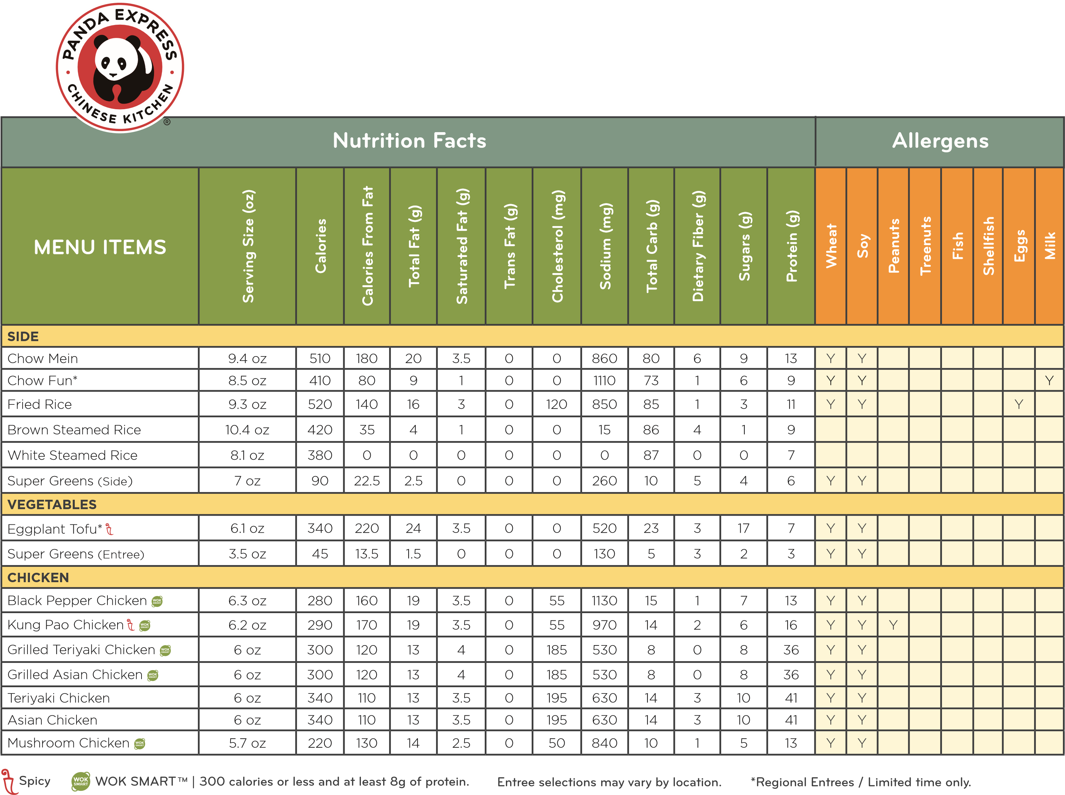

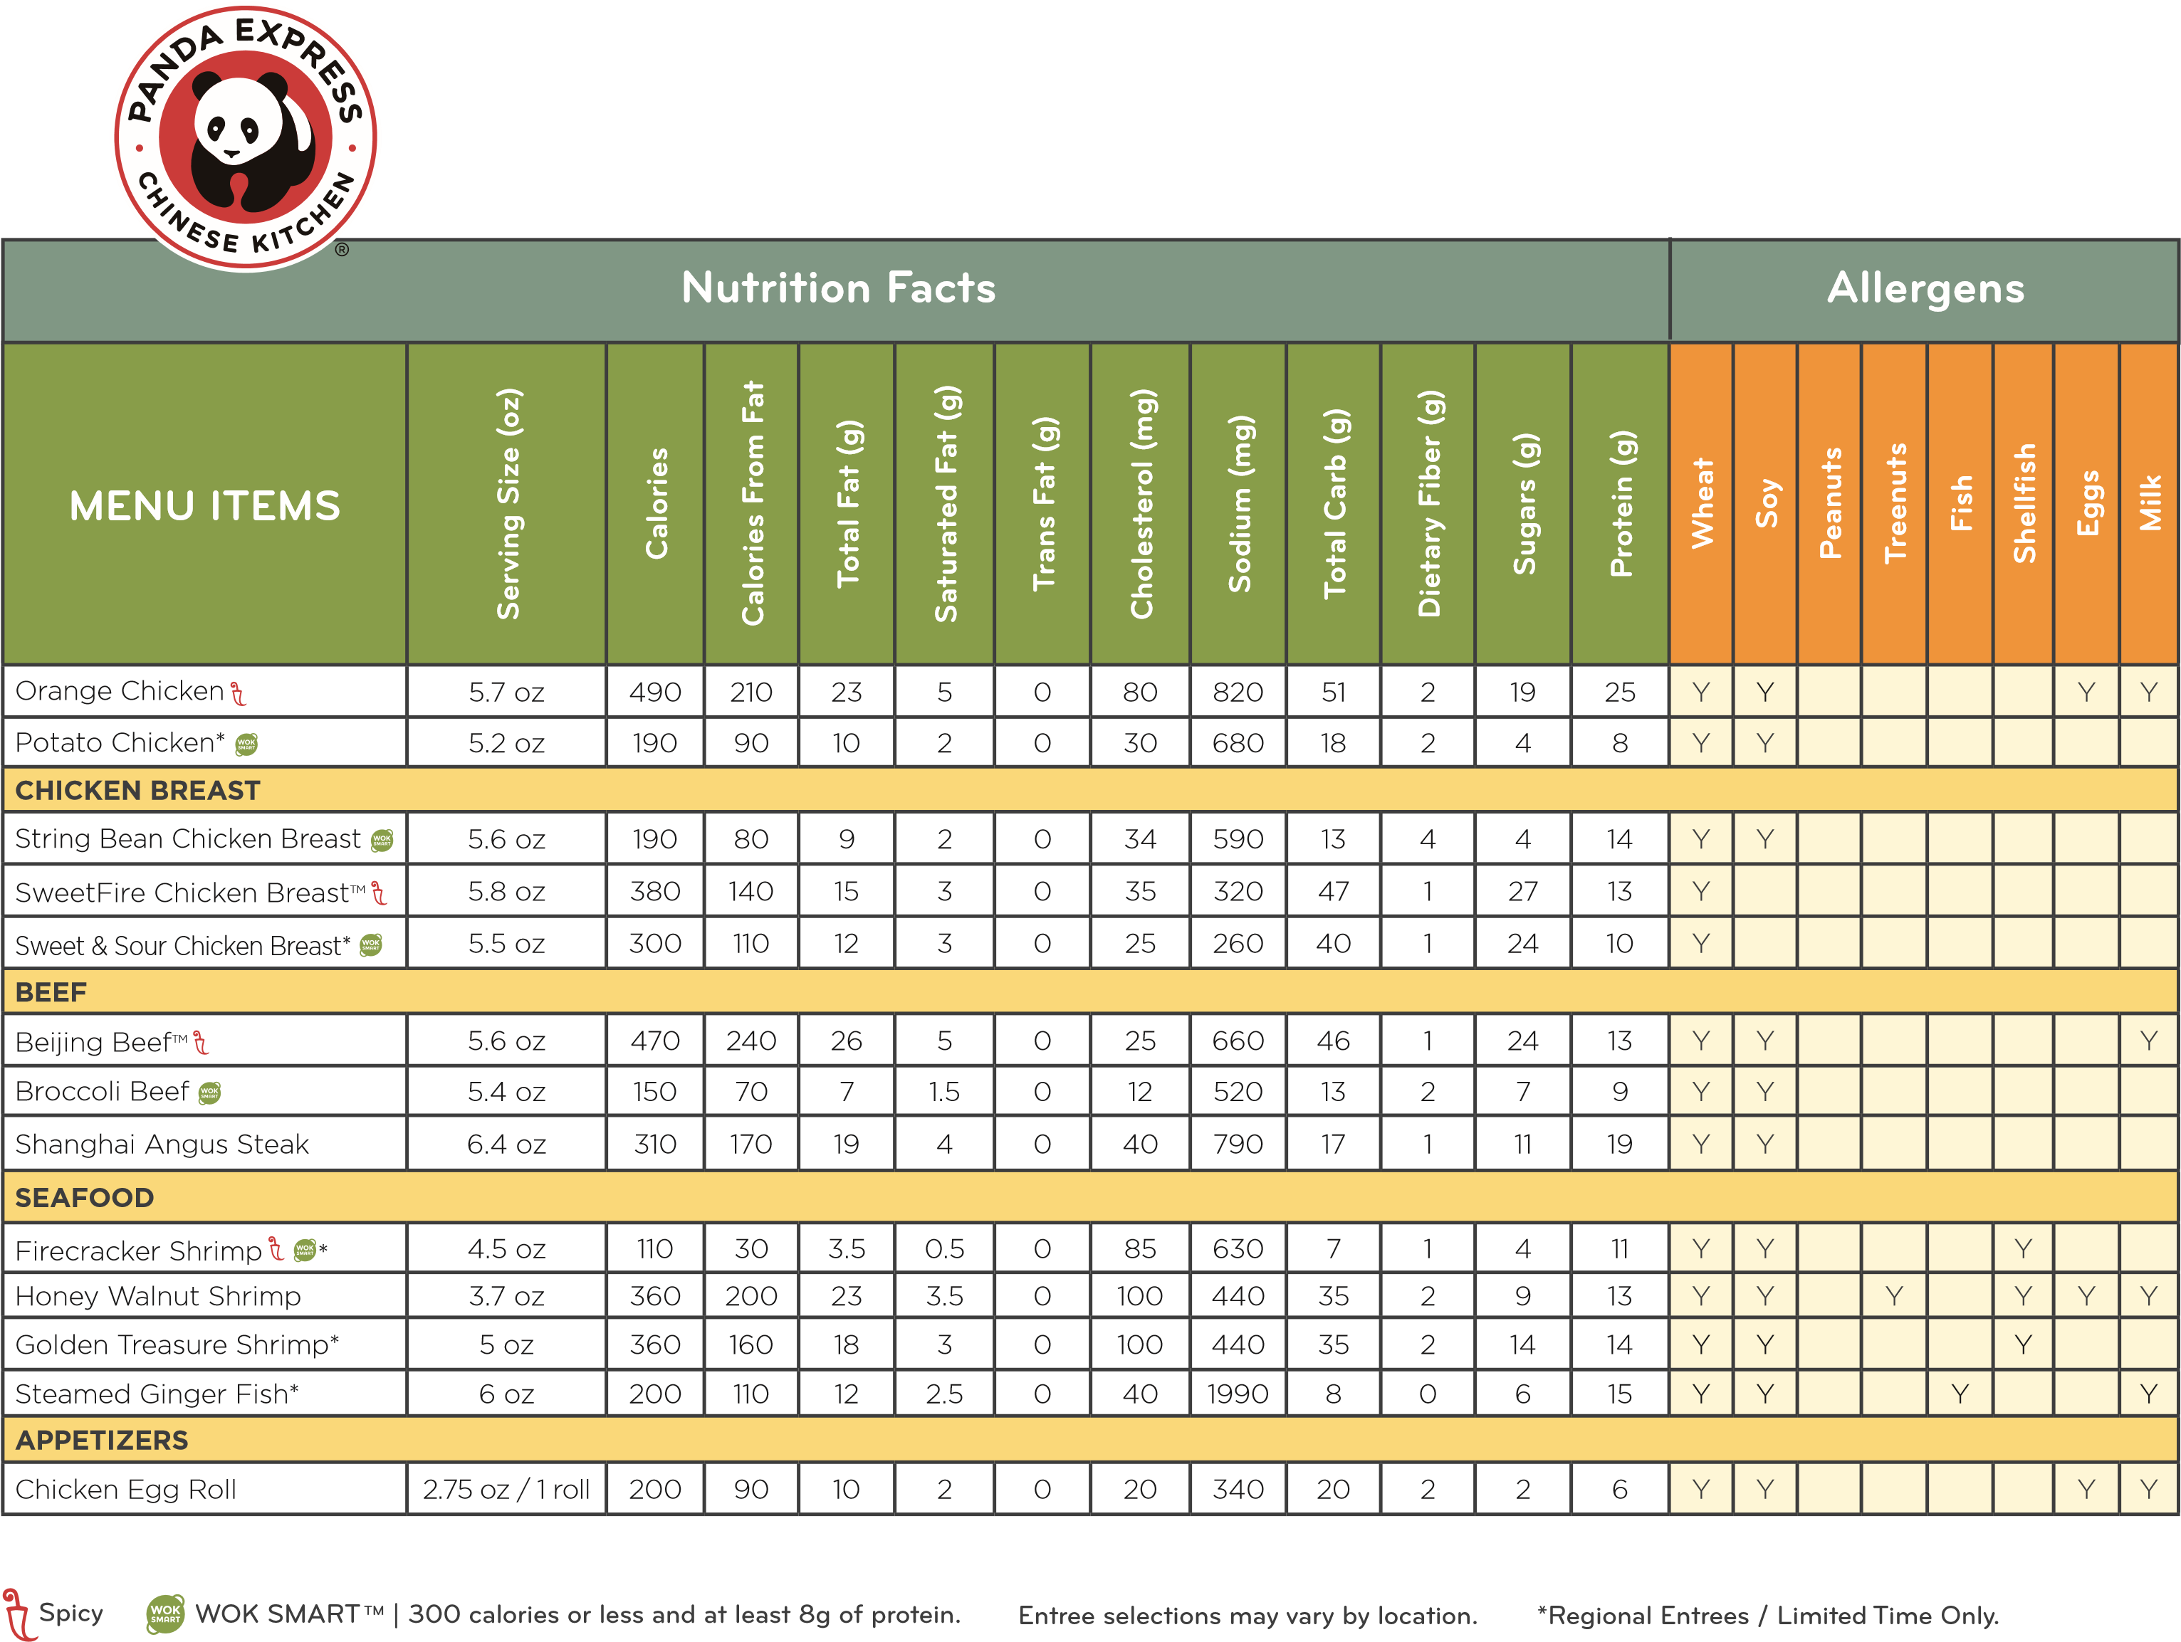

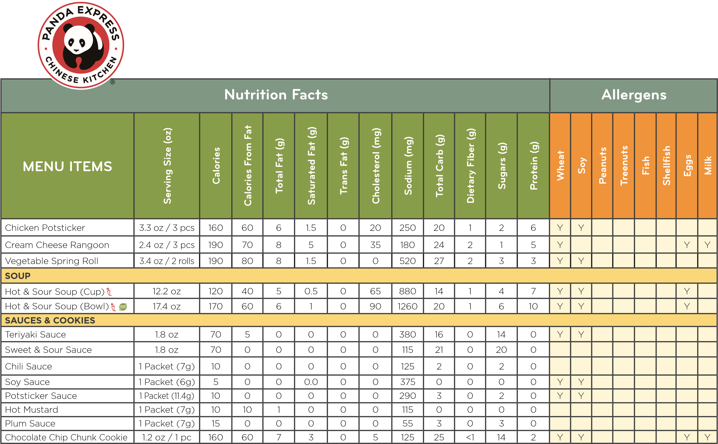

**SpicyWOK SMARTTM | 300 calories or less and at least 8g of protein. Entree selections may vary by location. *Regional Entrees / Limited Time Only.**

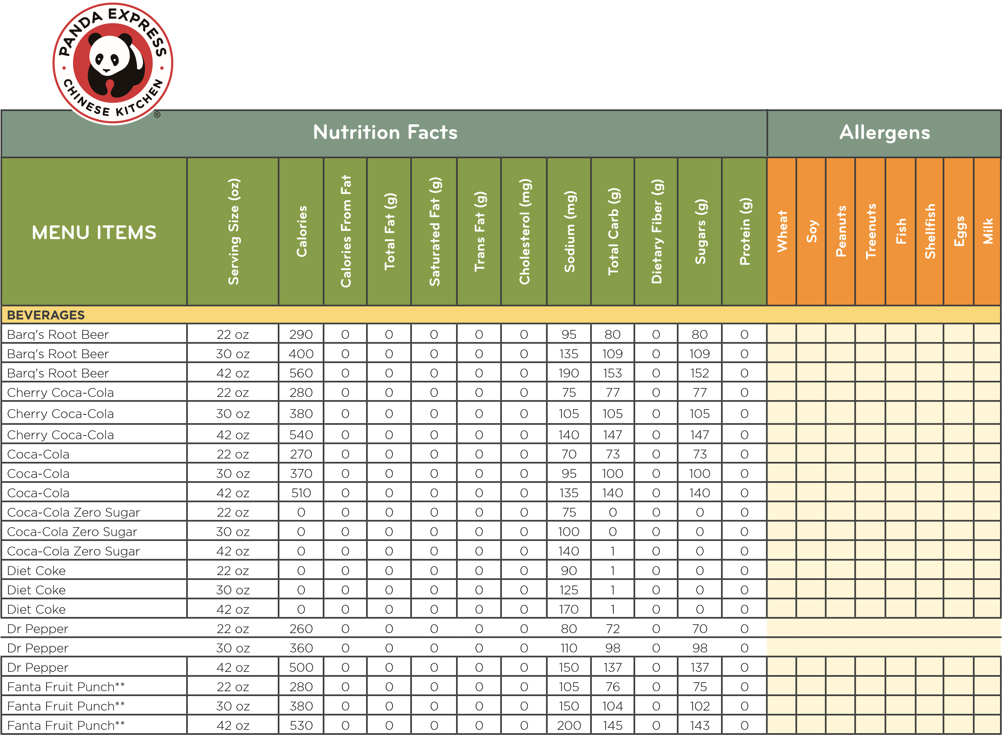

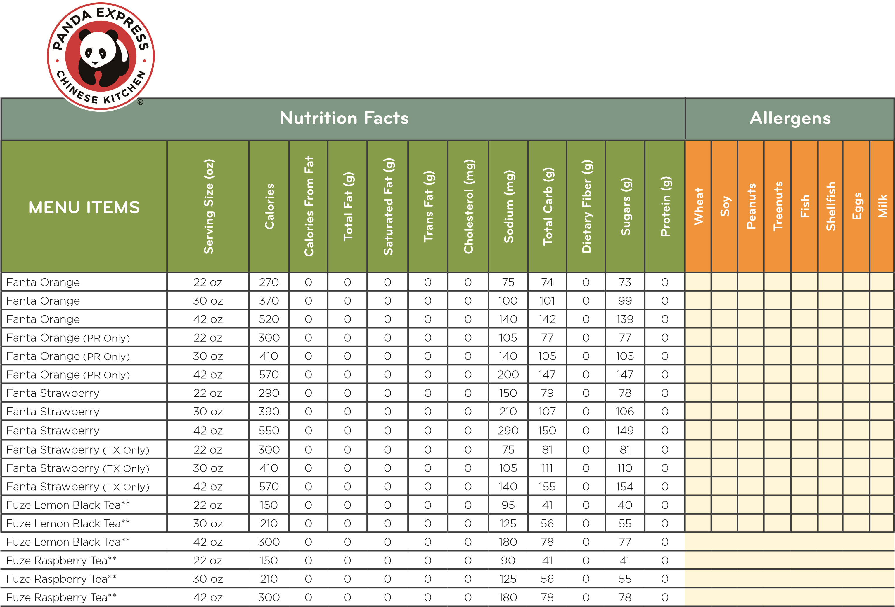

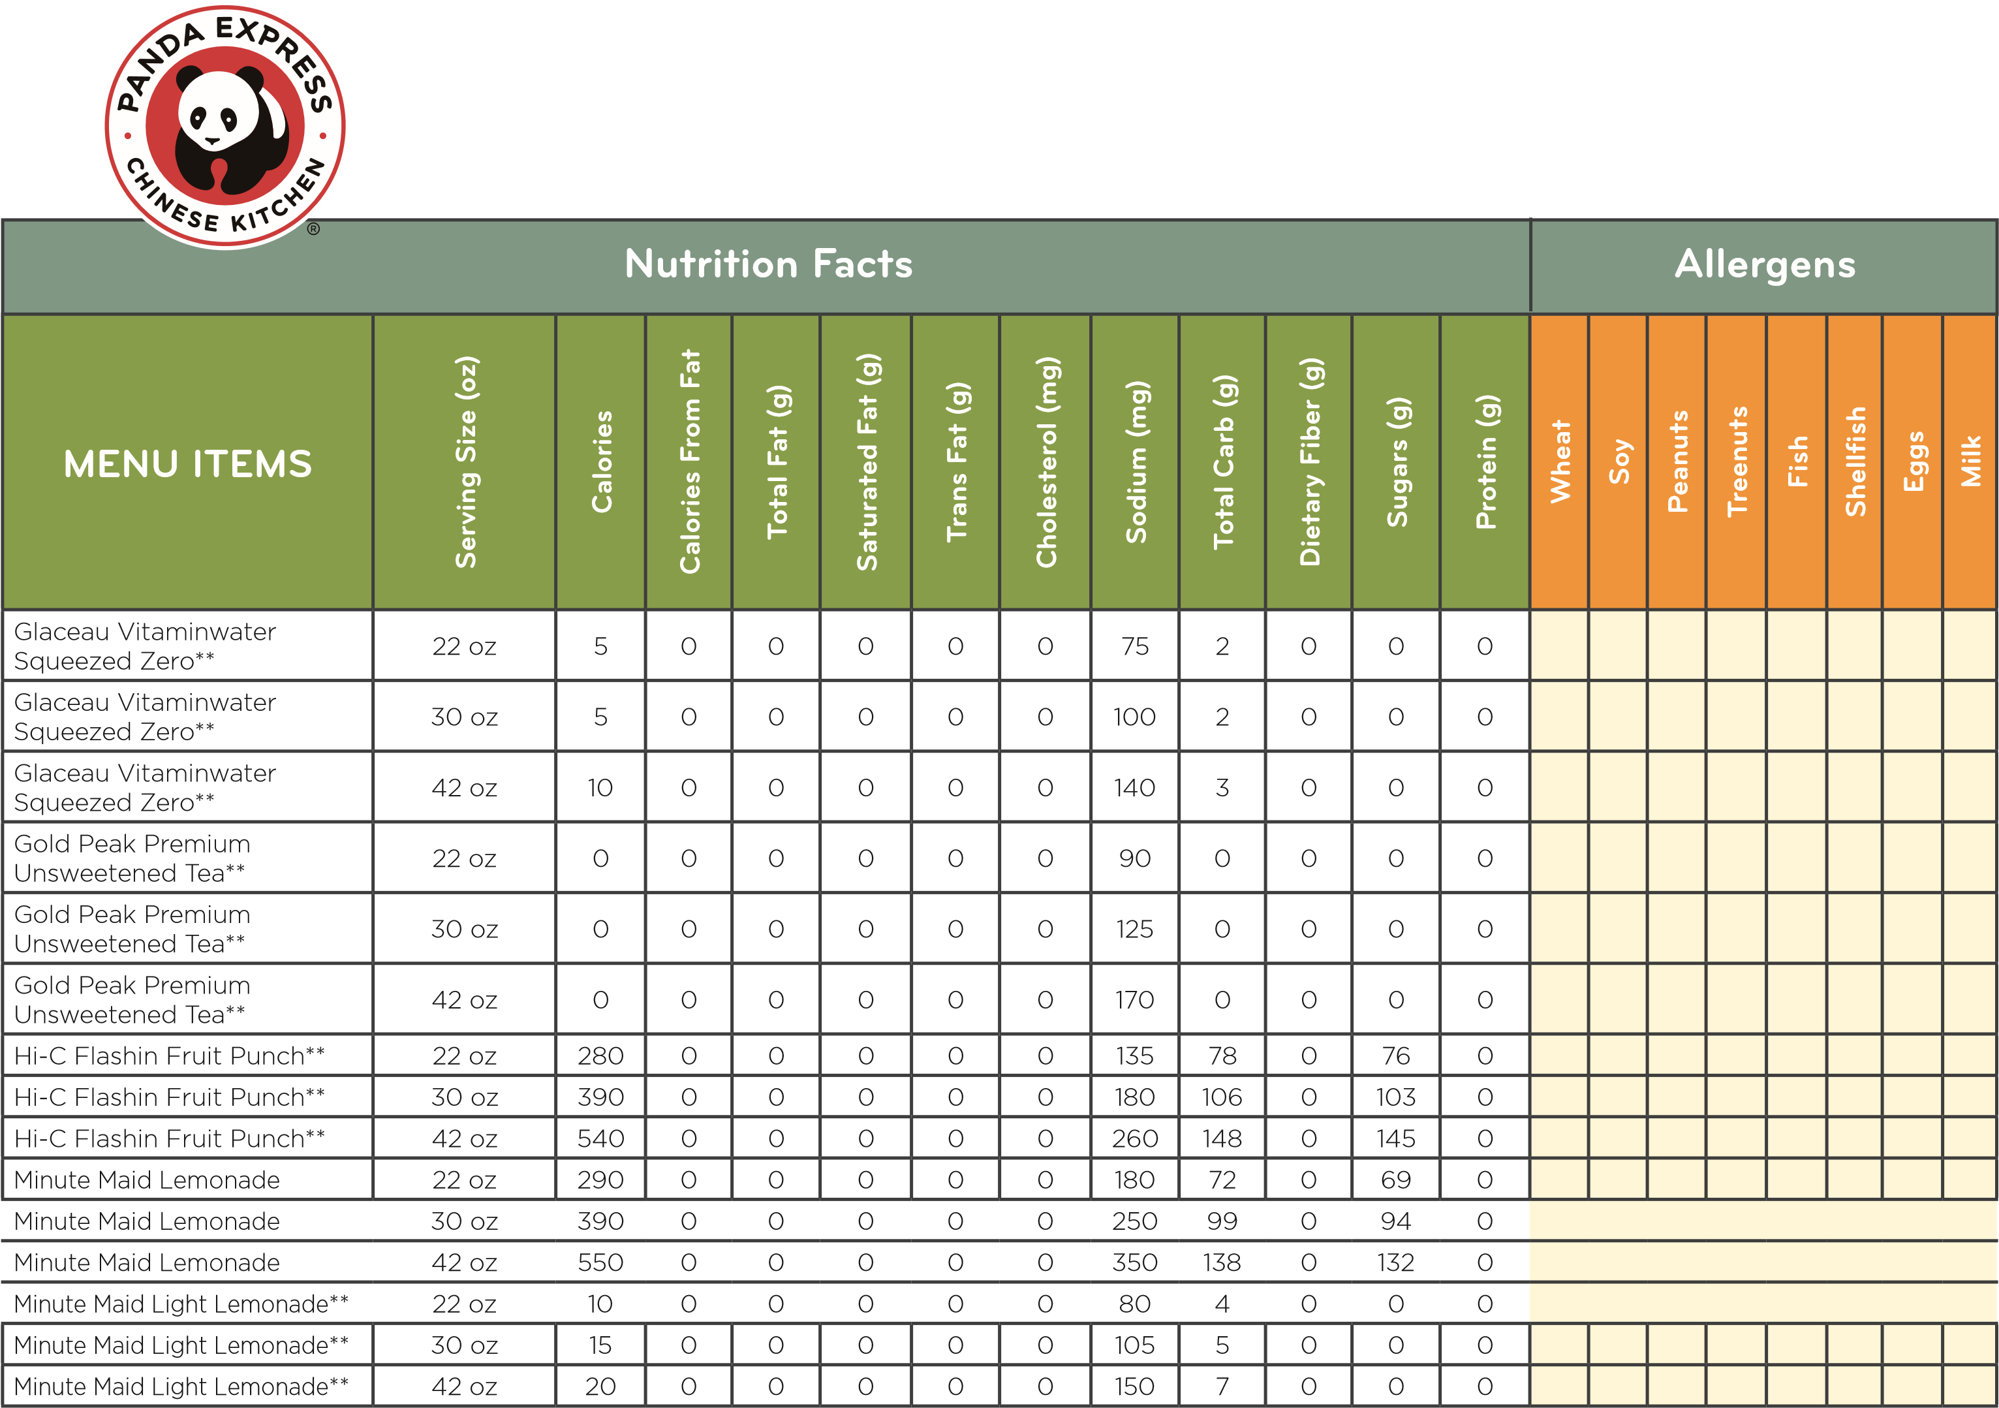

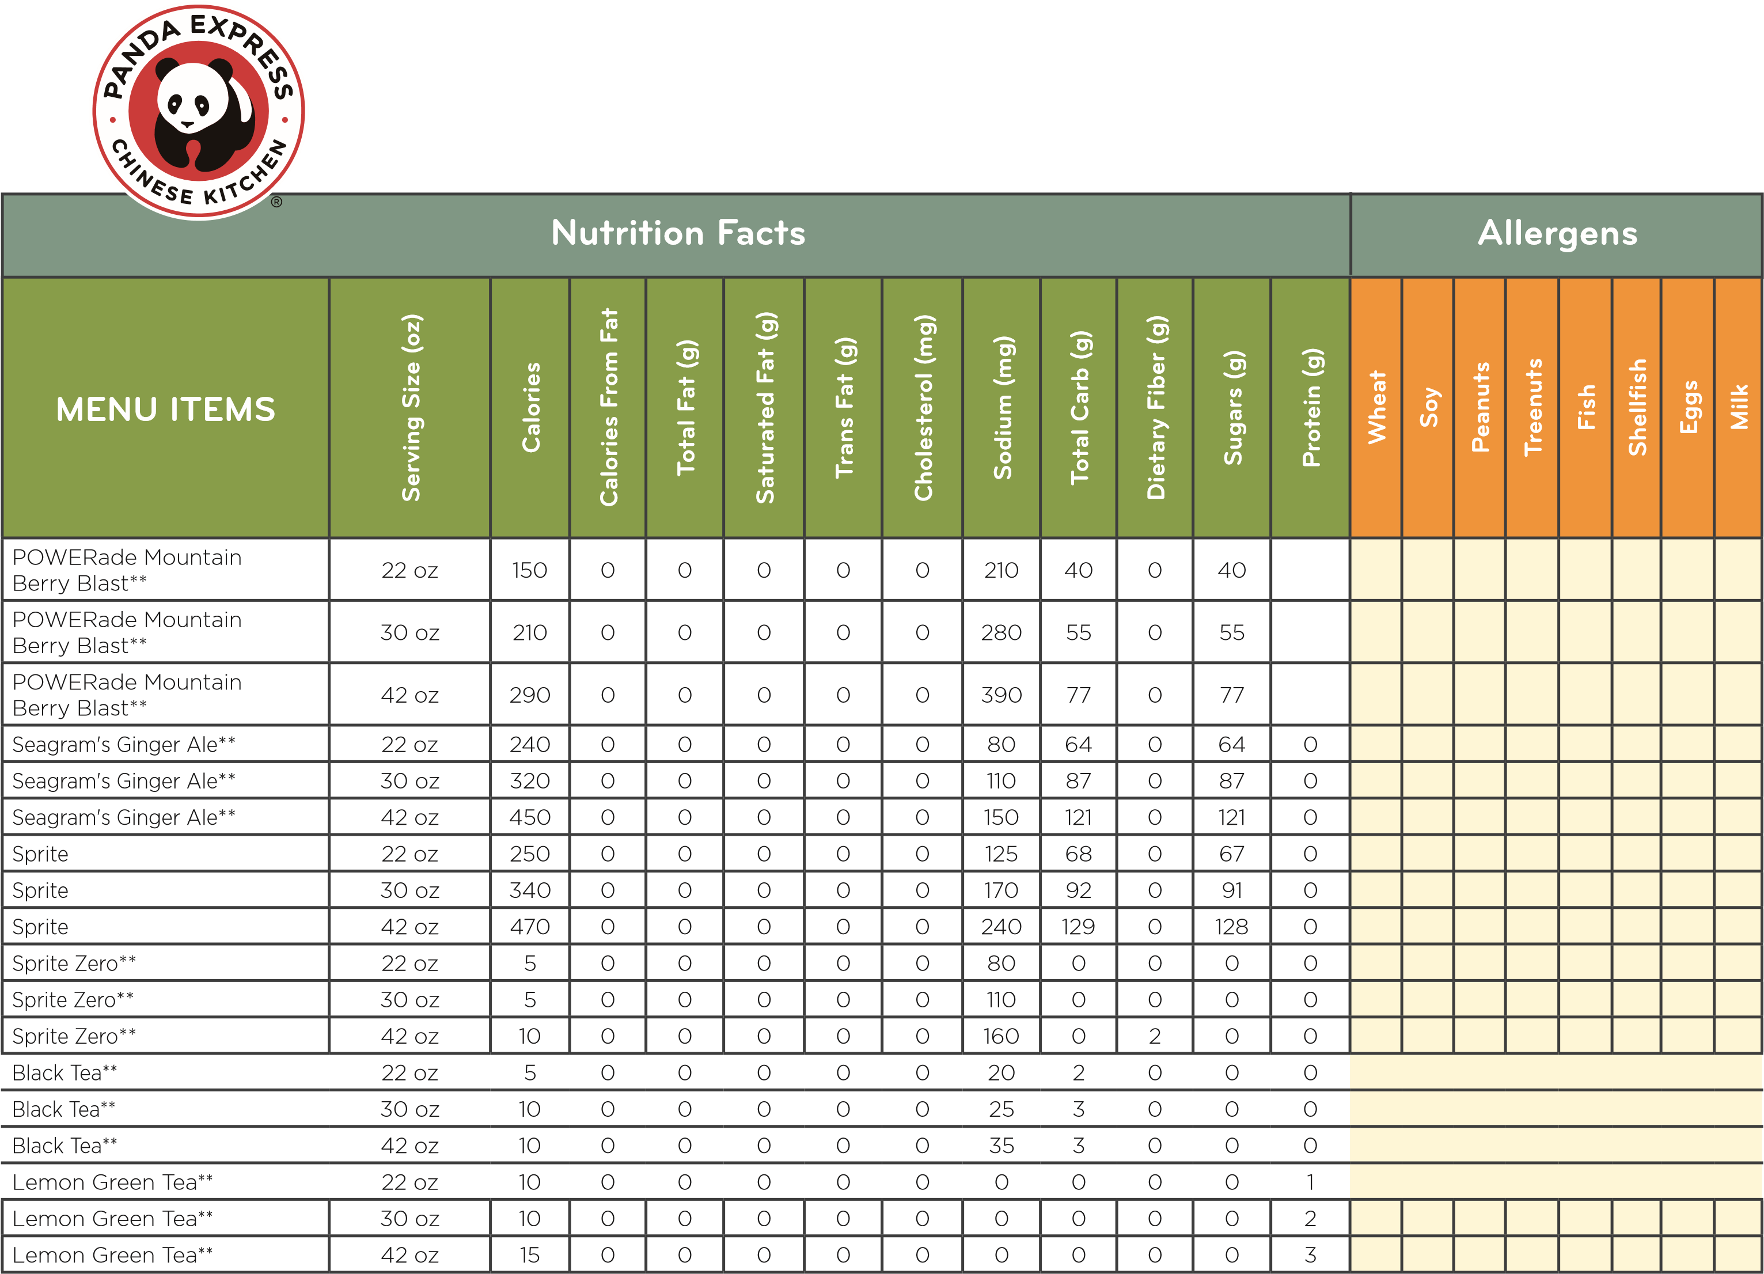

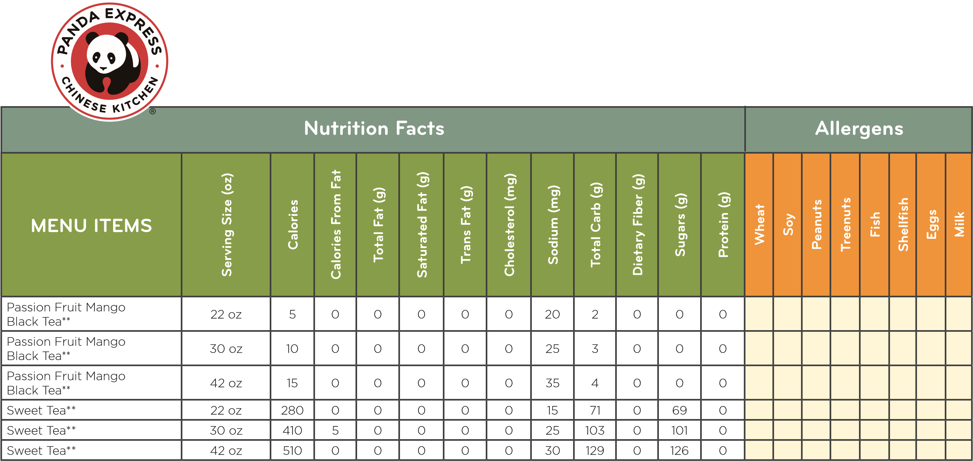

Nutrition information for the cup sizes and ice amounts are approximate values based on FDA-prescribed rounding rules. Actual nutritional values will vary based on cup fill level, type and precise amount of ice, and fountain equipment performance. Due to variations in sodium contributions from water, the sodium level of our fountain beverages may vary.

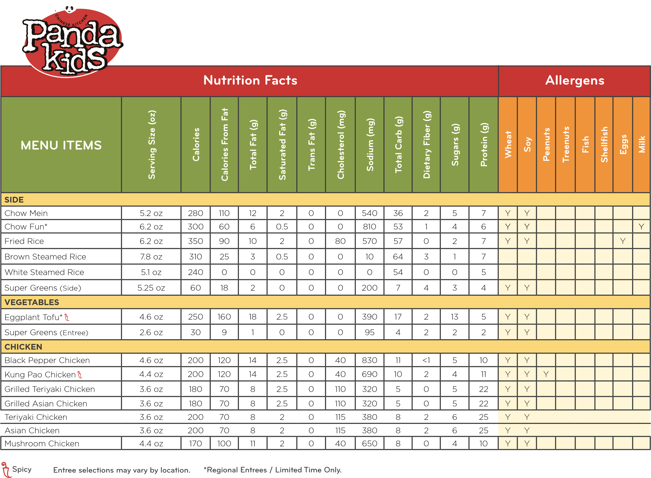

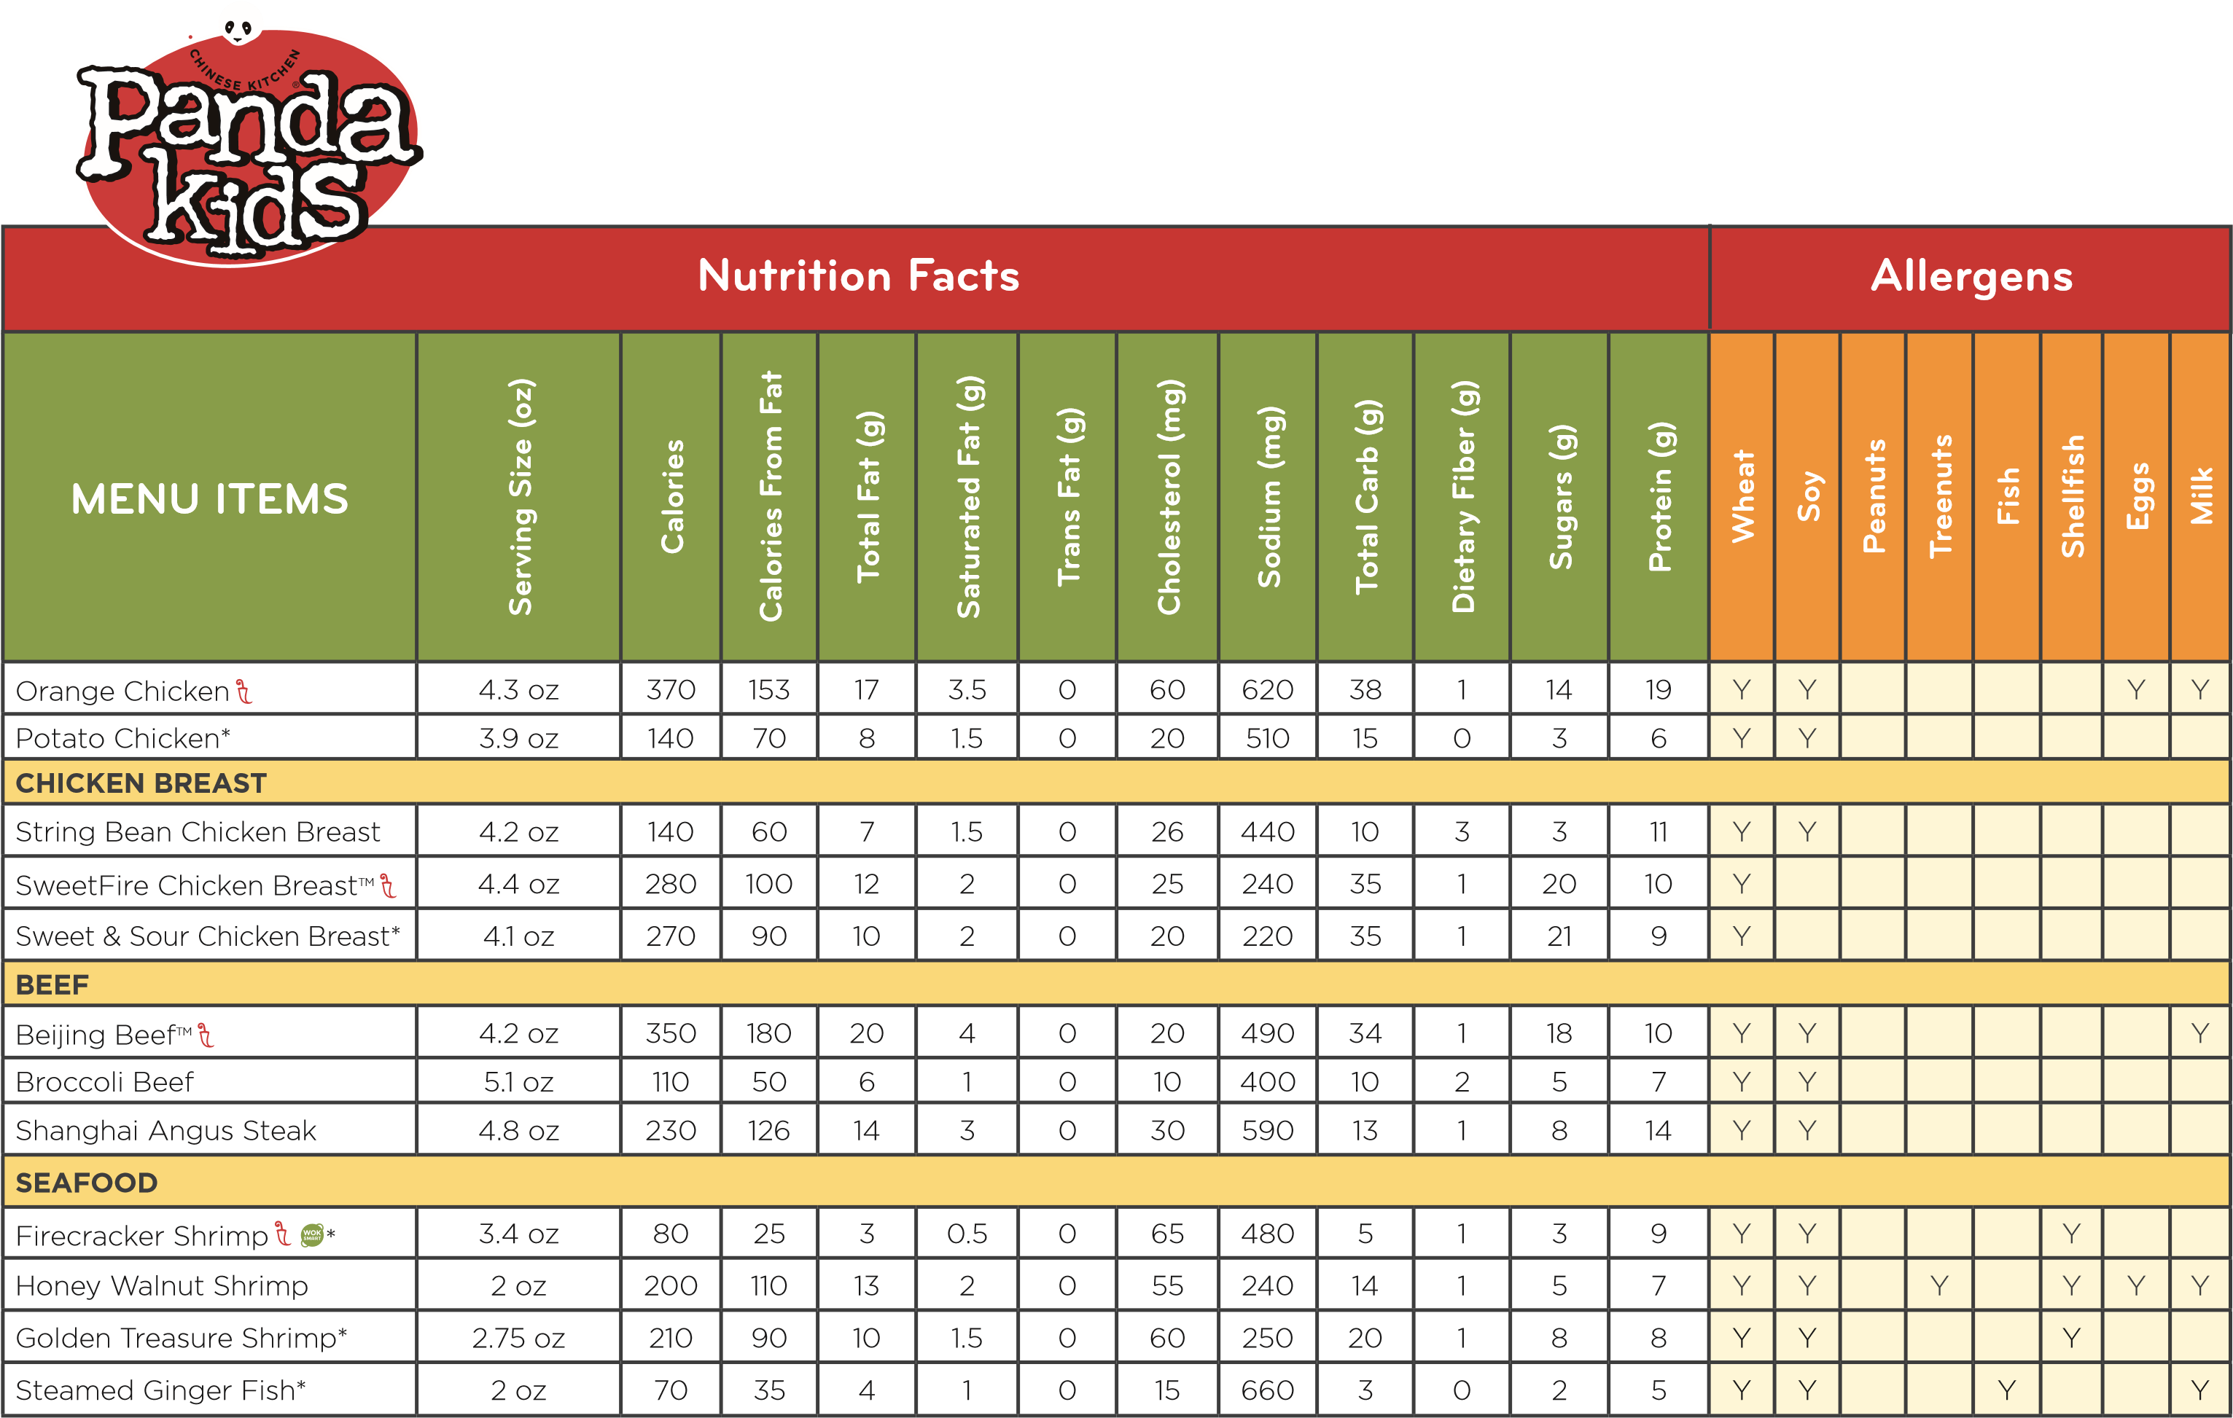

**Spicy Entree selections may vary by location. *Regional Entrees / Limited Time Only.**

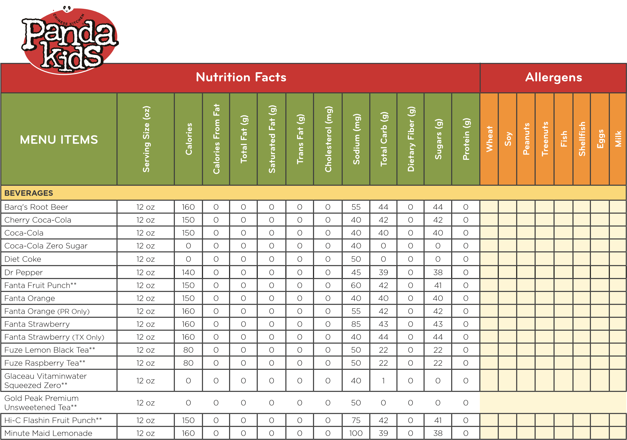

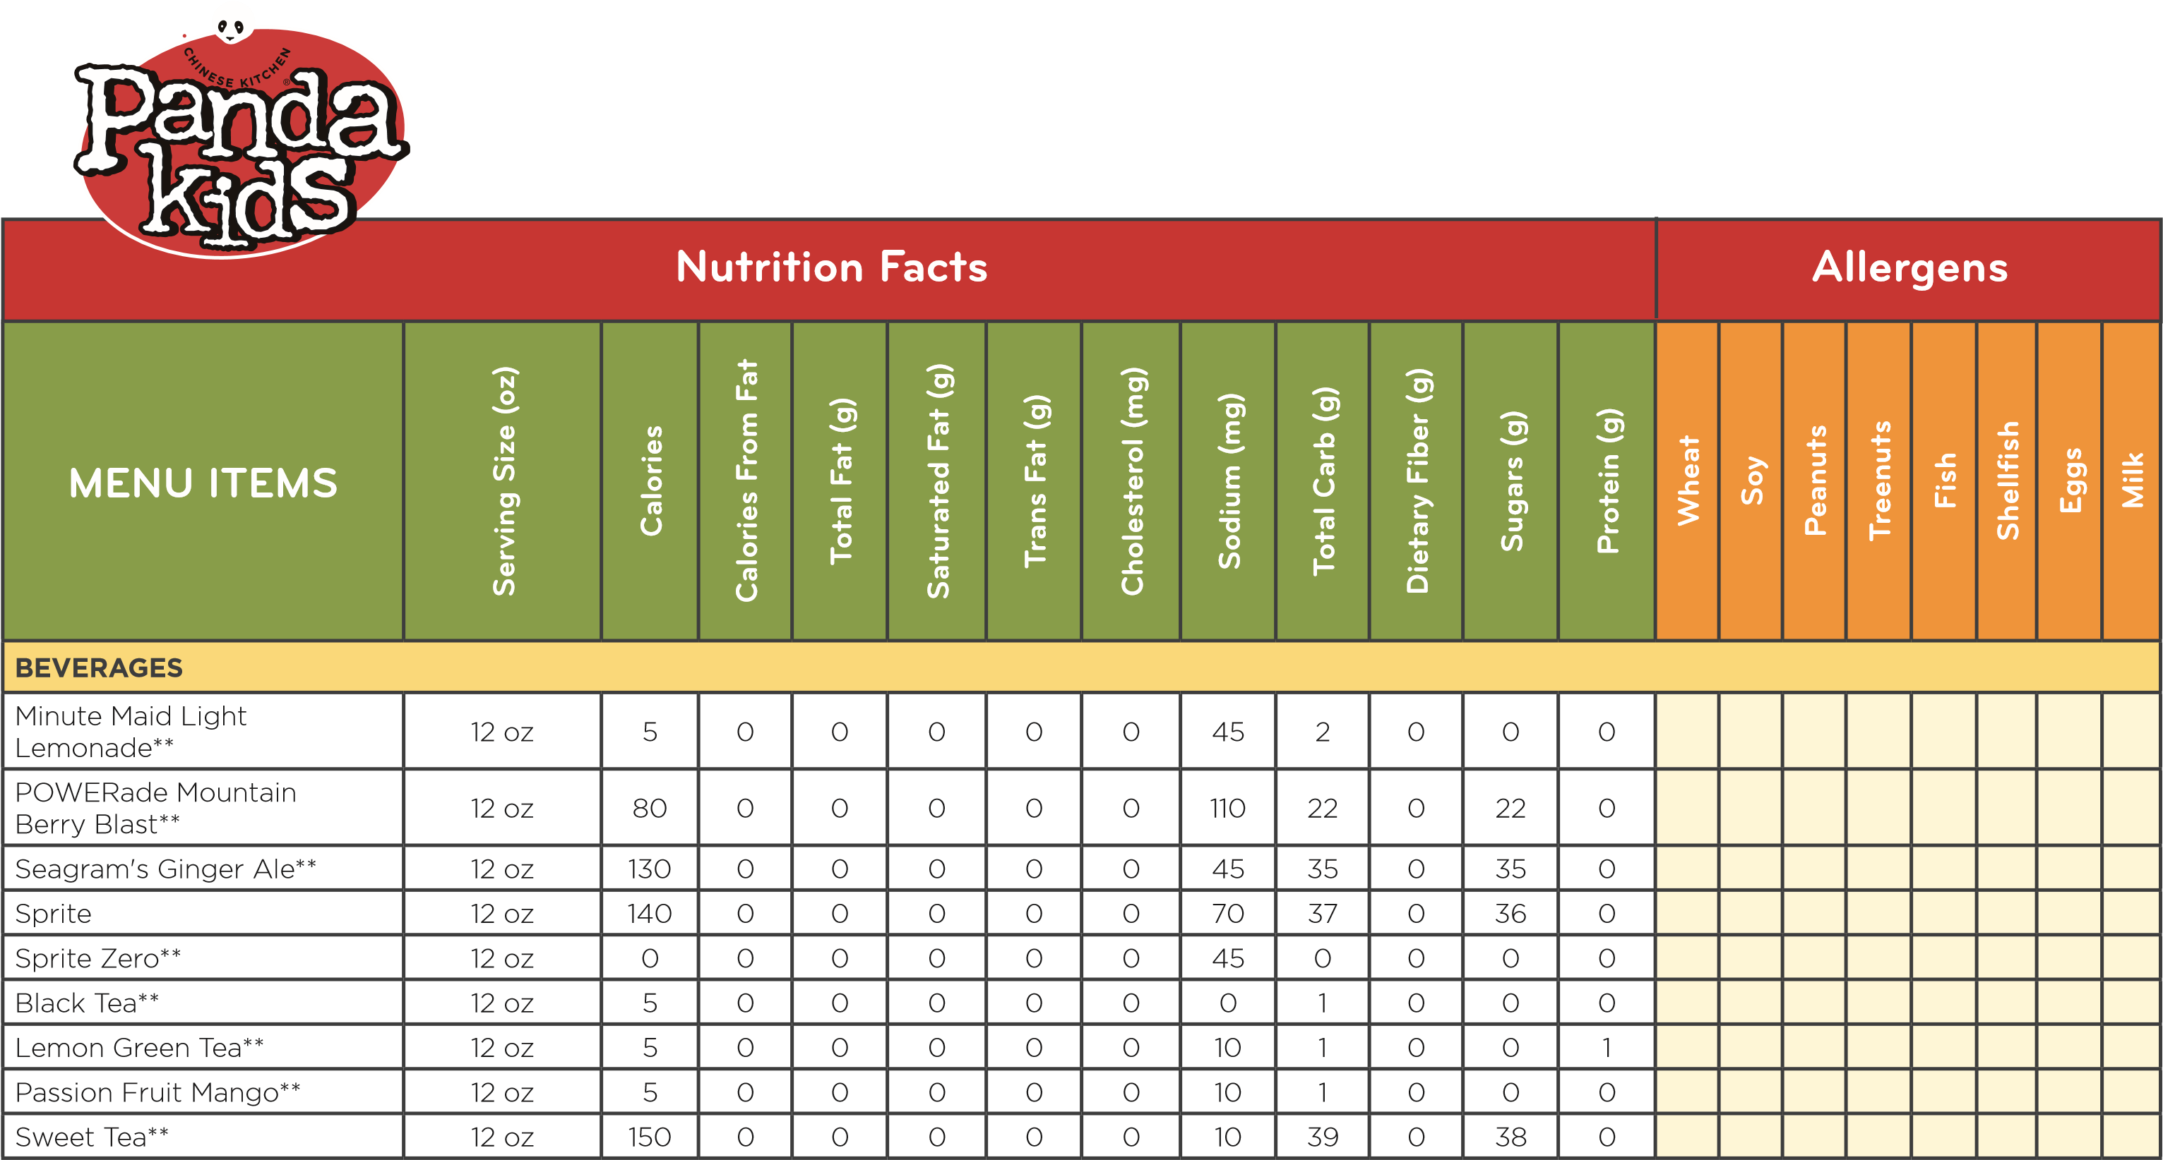

Nutrition information for the cup sizes and ice amounts are approximate values based on FDA-prescribed rounding rules. Actual nutritional values will vary based on cup fill level, type and precise amount of ice, and fountain equipment performance. Due to variations in sodium contributions from water, the sodium level of our fountain beverages may vary.

# NUTRITION & ALLERGEN INFORMATION

The Dietary Guidelines for Americans recommend limiting saturated fat to 20 grams and sodium to 2,300 milligrams for a typical adult eating 2,000 calories daily. Recommended limits may be higher or lower depending upon daily calorie consumption. These values are based on standard product formulation. Minor acceptable variations can be expected due to sampling differences, product assembly, seasonal influences and regional suppliers. Promotional entrees have not been included.

Ingredients are based upon standardized recipes. Variations in nutrition values may occur based upon regional and seasonal ingredient differences, packaging differences and menu items being individually hand served. Panda uses ingredients that contain all the major FDA allergens (peanuts, tree nuts, eggs, fish, shellfish, milk, soy and wheat). Panda prepares its entrees fresh with shared cooking equipment and therefore allergens could be present in any entree. Panda Express does not have any vegetarian or gluten free dishes. No MSG added except for that naturally occurring in certain ingredients.

**For additional menu information, please contact us at (800) 877-8988 or pandaexpress.com/contactus.**

©2020 Panda Restaurant Group, Inc. All Rights Reserved. 1/20